|  |  |  |  |  |
| --- | --- | --- | --- | --- |
| **POLYTECHNIC UNIVERSITY OF THE PHILIPPINES**  **COLLEGE OF ENGINEERING**  **COMPUTER ENGINEERING DEPARTMENT**      TOTAL QUALITY IN COMPUTER ENGINEERING    Whistle Flashlight For Emergency Survival Tool    TECHNICAL AND FUNCTIONAL  DOCUMENT    Section BSCOE 5-1D  Group No 3 | | | | |
| **NO** | **MEMBERS (Alphabetical Order)** | **CRITERIA** | **GRADE** |  |
| 1 | Cagomoc Niña Jaira Lael | Document Format Consistency (10%) |  |
| 2 | Calilung, Kristal |
| 3 | Kitts, Johndell | Complete TS Design, Components) (20%) |  |
| 4 | Macatangay senon jayson |
| 5 | Tan, Frederick | Complete TS Test Parameters and Procedures (20) |  |
| 6 |  |
| 7 |  | Complete FS on Procedures and Manuals) (10%) |  |
| 8 |  |
| 9 |  | Final Assembly Quality (40%) |  |
| 10 |  |
| **FINAL GRADE**      Instructor    **DR. LUTZ REYES**  2022 | | | |

|  |  |  |  |  |
| --- | --- | --- | --- | --- |
| **1. CHANGE RECORD:** | |  |  | |
| **Date** | **Author** | **DocVer** | **Change Reference** |  |
| 04-27-  2022 | * Cagomoc Niña   Jaira Lael   * Calilung,   Kristal   * Kitts, Johndell * Macatangay senon jayson * Tan, Frederick | Version  1.0 | Initial Draft |
|  |  |  |  |
|  |  |  |  |
|  |  |  |  |
|  |  |  |  |
|  |  |  |  |
|  |  |  |  |
|  |  |  |  |
|  |  |  |  |
|  |  |  |  |
|  |  |  |  |
|  |  |  |  |
|  |  |  |  |
|  |  |  |  |
|  |  |  |  |
|  |  |  |  |
|  |  |  |  |
|  |  |  |  |
|  |  |  |  |
|  |  |  |  |
|  |  |  |  |
|  |  |  |  |
|  | | | |

|  |
| --- |
| **TECHNICAL SPECIFICATION DOCUMENT** |

|  |
| --- |
| 1. **INDIVIDUAL COMPONENTS:**      * 1. **Description:**     Whistle flashlight is a must-have product for everyone. It is easy to use and carry and this will help people in times of disaster by sending distress signals far away using the flashlight or distress sounds using a whistle.     * 1. **Features:**     It has a built in SOS distress signal  It is light and portable  It comes in many colors     * 1. **Applications:**     A survival tool for emergencies and disasters     * 1. **Components/Device Information:**     Flashlight  Whistle  SOS distress signal Circuitry |

**3.**

**DIAGRAMS**

**:**

*3.1.*

**Schematic Diagrams:**

*3.2.*

**Drawings and Wireframes:**

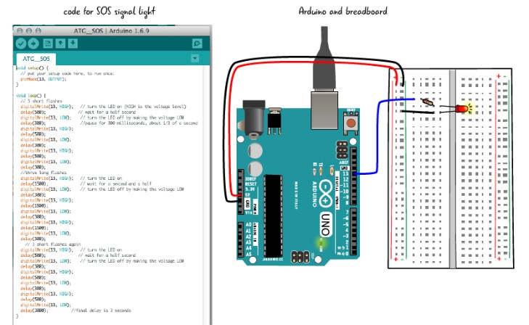

|  |
| --- |
|  |

|  |
| --- |
| 1. **COMPONENTS USED:**      * 1. **Detailed Description:**      * 1. **Overview:**      * 1. **Feature Description:**       1. **Product Technical Spec**      * + 1. **Product Dimension:**         1. **Top View:**      * + - 1. **Side View:**      * + - 1. **Internal View:**      * + 1. **Printed Circuit Board Side View:**      * + 1. **Screws - Side and Top View:**      * + 1. **Components Technical Specification:**      * + 1. **Detailed Step-by-Step Procedure:**         1. **Assembly Instruction:**      * + - 1. **Test instructions, Parameters and process for quality:**      * + 1. **Time and Motion Activities:**      * + 1. **Flow Chart:**      * + 1. **Quality Tools Used for Defect Monitoring**         1. **Defect List or Check List Summary**      * + - 1. **Fishbone Analysis for all Defects** |

|  |
| --- |
| **FUNCTIONAL SPECIFICATION DOCUMENT** |

|  |
| --- |
| 1. **EXTERNAL DETAILED DRAWING OF THE PRODUCT WITH PARTS:**            1. **FUNCTIONS OF EACH PARTS:**            1. **STEP BY STEP PROCEDURE ON HOW TO USE THE PRODUCT:**            1. **INDICATE MAINTENANCE PROCEDURES (IF ANY)** |

|  |  |  |  |  |  |  |  |  |  |  |  |  |  |  |  |  |  |  |  |  |  |  |  |  |
| --- | --- | --- | --- | --- | --- | --- | --- | --- | --- | --- | --- | --- | --- | --- | --- | --- | --- | --- | --- | --- | --- | --- | --- | --- |
| **9. SIGN OFF:** *(Signature of key sponsors, subject matter expert heads)*       |  |  |  |  | | --- | --- | --- | --- | | Name | Position | Signature | Date Signed | |  |  |  |  | |  |  |  |  | |  |  |  |  | |  |  |  |  | |  |  |  |  | |

Technical Specifications & Functional Specifications Documents - Page